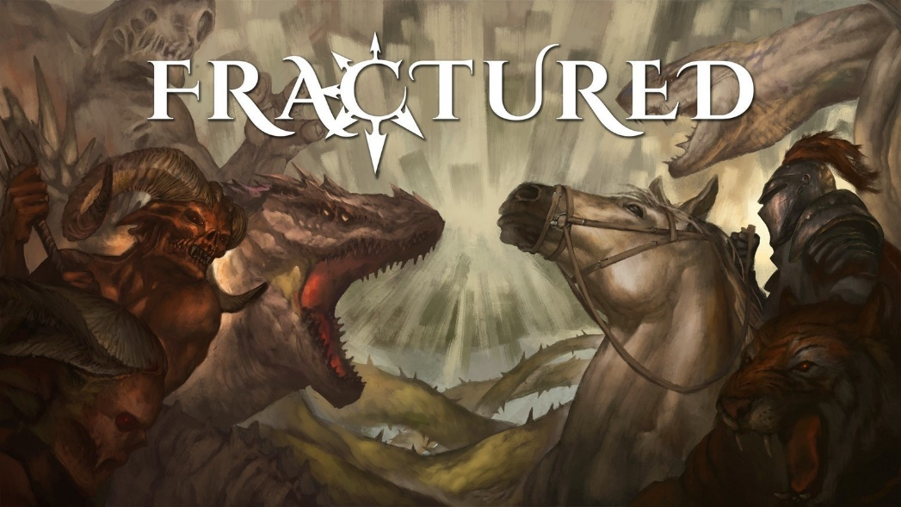
Dynamic MMORPG ‘Fractured’ enters Fall Alpha phase on September 22
For three weeks, players can check out several new additions to the open-world sandbox game while offering valuable feedback.
MILAN, ITALY, September 15, 2021 - Dynamight Studios is announcing its upcoming open-world sandbox MMORPG, Fractured, will soon be entering its Fall Alpha phase from September 22 through October 13. The update introduces a number of new abilities, world events, an overhaul of its equipment progression system, and much more.
The three-week Fall Alpha phase gives would-be adventurers the chance to test out Fractured’s new content while providing valuable feedback to the development team. Since its successful Kickstarter campaign in 2018, Dynamight Studios has felt player feedback to be an integral part of the development process and has identified their active and dedicated community as the studio's most important asset.
Fractured players will have plenty to offer their opinion on as the Fall Alpha phase adds a number of highly-anticipated features:
- Dozens of new abilities
- Dynamic world events
- PvP sieges
- New points of interest
- 20+ monsters to defeat
- Treasure chests and lockpicking
- Equipment and crafting systems expansion
- Overhaul of in-game marketplace and player attributes
Last – but certainly not least – Dynamight Studios will push its servers to the limits to ensure thousands of players can interact in the same world once Fractured releases in 2022.
For more information, or to take part in the Fall Alpha by becoming a founder, please visit Fractured’s official website.

Resources
Email: press@dymstudios.com
Press Kit: https://fracturedmmo.com/press-kit
Fractured Website: https://fracturedmmo.com
About Fractured
Fractured is Dynamight Studios’ upcoming open-world sandbox MMORPG featuring a dynamic open sandbox world, a player-driven economy, player-built cities across three worlds and multiple continents, combined with a skill-based and action-oriented gameplay known from isometric Action-RPGs like Diablo and Path of Exile.
Taking lessons from grindy MMORPGs that only cater to hardcore players, Fractured opens up its accessibility with a focus on horizontal progression, different PvP rulesets depending on the choice of playable race and planet, and making sure that short adventures and events ranging from 30 to 60 minutes of gameplay time feel rewarding, without compromising depth and complexity.
About Dynamight Studios
Dynamight Studios is an independent videogame development startup based in Milan, Italy.
Our mission is to innovate the world of Sandbox MMOs by opening it up to audiences that have been cut off from what we believe is the most exciting online game genre out there - and one with exceptional growth perspectives, too.
As of today, we are a team of 10 full-time employees (and full-time geeks), all focused on the development of Fractured, our flagship product through which we hope to make our dream your reality.

